SENTINEL ATTENDANCE
QR-Based Employee Attendance Management System
PROJECT REPORT
Submitted by
Melbin Paul - MGP25MCA-2046
Aivin Jinu - MGP25MCA-2009
Amina Salim - MGP25MCA-2015
Nandana Rajendran - MGP25MCA-2050
Under the guidance of
Ms. Vidya N

Department of Computer Applications
Saintgits College of Engineering, Pathamuttom, Kottayam
2025-27

ABSTRACT
The Employee Attendance Management System, Sentinel, is a two-part platform built to replace manual, paper-based, and spreadsheet-driven attendance tracking. It consists of a web application, used exclusively by Managers and Administrators, and a separate mobile application, used by Employees to mark their own attendance and manage their leave requests. Both applications operate against the same MongoDB database, but the mobile application does not write to the database directly. It communicates only through the same backend REST API used by the web application, which keeps every validation rule (QR signature and expiry checks, working-hours computation, role checks) enforced in one place for both clients.
Attendance is recorded through a QR code that is generated by the backend, cryptographically signed, and regenerated every few seconds. It is displayed on a screen at the office premises and scanned by the employee through the mobile application. Because each code expires within seconds and needs the server’s private signing key to be regenerated, a screenshotted code cannot be reused. The web application gives administrators a live dashboard, employee and department management, organisation-wide reports, and leave approval. The mobile application lets employees scan the attendance QR, view their own attendance history, and submit and track leave requests.
The system is organised into four modules. User Authentication and Employee Management provides shared login and role-based access, TOTP two-factor authentication for Manager and Administrator accounts, and employee and department record management. Smart Attendance and QR Verification covers server-side generation and signing of rotating QR codes, the kiosk-facing display, and the verification endpoint that includes signature and expiry checks, duplicate-scan prevention, and working-hours and status computation. Admin Dashboard and Analytics provides attendance trends, absenteeism and late-arrival analytics, department-wise comparisons, and report generation and export. Leave Management and Employee Self-Service covers leave submission and tracking on mobile, the approval workflow on the web, and automatic reconciliation into attendance once a request is approved.
The web application is built with React.js, Node.js, Express.js, and MongoDB hosted on MongoDB Atlas, so that the web backend and the separately built mobile application connect to the same shared instance. Sign-in for both applications is handled by the backend itself: passwords are hashed with bcrypt and verified sessions are issued as signed JSON Web Tokens (JWT), which also allows TOTP to be enforced as a second factor for Manager and Administrator accounts. The QR signing and verification logic is implemented once in the backend and shared by both clients. Overall, Sentinel makes attendance automated and tamper-resistant within the scope of a four-member project.

TABLE OF CONTENTS
1. Introduction
2. Problem Statement
3. Objectives
4. Scope of the Project
5. Existing and Proposed Systems
6. System Requirements
7. Technologies Used
8. System Architecture
9. Major Modules
10. Data Design and Storage
11. Implementation Overview
12. Testing and Validation
13. Limitations
14. Future Enhancements
15. Conclusion
References

1. INTRODUCTION
Attendance records are the foundation of workforce management. They determine working hours, support leave and payroll decisions, and reveal patterns such as absenteeism and habitual late arrival. In many organisations these records are still kept in paper registers or spreadsheets, which are slow to update, easy to alter, and difficult to analyse.
Sentinel is an Employee Attendance Management System designed to automate this process. It is a two-part platform. Managers and Administrators use a web application to manage employees and departments, monitor a live dashboard, approve leave, and generate reports. Employees use a separate mobile application to mark their own attendance by scanning a QR code and to manage their leave requests. Attendance is recorded when the employee scans a QR code displayed at the office premises. The code is generated and cryptographically signed by the backend and regenerated every few seconds, so a screenshot or forwarded image quickly becomes useless.
Both applications are clients of a single Express.js backend and a shared MongoDB database. The mobile application never accesses the database directly; it calls the same authenticated REST endpoints as the web application. The system is organised into four modules, each assigned to one member of the four-member project team.

2. PROBLEM STATEMENT
Manual, paper-based, and spreadsheet-driven attendance tracking has several weaknesses. Entries are written or typed by hand and can be delayed, mistyped, or altered afterwards. Employees can mark attendance on behalf of absent colleagues. Static QR codes or shared links can be photographed and reused from outside the premises. Administrators have no live view of who is present, and approved leave must be reconciled against attendance records by hand.
Sentinel addresses these problems by combining short-lived signed QR codes, duplicate-scan prevention, two-factor authentication for privileged accounts, a live analytics dashboard, and automatic reflection of approved leave in attendance records. Because all validation runs in one backend, the same rules apply whichever client sends a request. The actual level of tamper resistance depends on correct configuration of the signing key and the refresh interval, and must be verified in the deployed build.

3. OBJECTIVES
- To develop a two-part platform, a web application for Managers and Administrators and a mobile application for Employees, that replaces manual and spreadsheet-based attendance tracking.
- To provide login and role-based access, with employee accounts created by an Administrator and used only to sign in on the mobile app.
- To protect Manager and Administrator accounts on the web application with TOTP two-factor authentication.
- To record attendance through a backend-generated, cryptographically signed QR code that is regenerated every few seconds.
- To prevent reuse of expired codes and duplicate scans, and to compute working hours and attendance status automatically.
- To enforce every validation rule once, in the shared backend REST API, for both clients.
- To give administrators a live dashboard, department-wise analytics, and exportable organisation-wide reports.
- To let employees submit and track leave requests from the mobile app, with Manager or Administrator approval on the web and automatic reconciliation into attendance.

4. SCOPE OF THE PROJECT
The project scope covers the React.js web application, the separately built mobile application, the Node.js and Express.js backend REST API, and the shared MongoDB Atlas database. It includes backend-based authentication using bcrypt and JWT, TOTP for Manager and Administrator accounts, employee and department management, QR generation, signing and verification, the kiosk-facing QR display, analytics and reports, and leave management.
The scope is deliberately sized for a four-member team. Each member owns one module that is substantial and independently demonstrable. The mobile application is maintained as a separate codebase but is treated as a second client of the same backend. Payroll processing, biometric or face verification, and location-based validation are not part of the described scope and are treated as possible future enhancements.

5. EXISTING AND PROPOSED SYSTEMS

5.1 Existing System
In a typical manual workflow, attendance is written in a register or entered into a spreadsheet, leave requests are handled through paper forms or messages, and reports are compiled by hand at the end of a period. This is the general problem context; it is not a measured comparison with a specific product.

5.2 Proposed System
Sentinel proposes a platform in which employees mark attendance from their own phones by scanning a signed, rapidly expiring QR code, while Managers and Administrators run the organisation from a web console. The table below summarises the general differences.
Aspect | Manual / spreadsheet process | Sentinel
Recording | Handwritten or typed entries | QR scan from the employee’s mobile app, verified by the backend
Tamper resistance | Entries can be altered or entered on behalf of others | Signed, short-lived QR codes; expired or duplicate scans are rejected
Privileged access | Shared files or passwords | Password plus TOTP for Manager and Administrator accounts on the web
Visibility | Compiled periodically | Live dashboard with trends and department-wise comparisons
Leave handling | Manual reconciliation with attendance | Submitted on mobile, approved on web, reconciled automatically
Validation | Depends on the person keeping the records | Enforced once in the shared backend for every client

6. SYSTEM REQUIREMENTS

6.1 Hardware Requirements
- A server or development machine capable of running Node.js and the Express.js backend.
- A screen or kiosk display at the office premises to show the rotating QR code.
- A smartphone with a working camera for each employee to run the mobile application.
- A desktop or laptop with a modern browser for Managers and Administrators.
- Internet connectivity for both clients, the backend, and the MongoDB Atlas database.

6.2 Software Requirements
- Operating system: Windows, Linux, or macOS for development and hosting.
- Runtime and package manager: Node.js and npm.
- Web frontend: React.js.
- Backend: Express.js on Node.js, exposing a REST API.
- Database: MongoDB, hosted on MongoDB Atlas.
- Mobile application: a separate codebase built with [MOBILE FRAMEWORK - to be specified] and installed on employees’ phones.
- An authenticator application on Manager and Administrator phones for TOTP codes.
- Development tools: Visual Studio Code or an equivalent editor, and a modern web browser.

7. TECHNOLOGIES USED
Technology | Area | Purpose
React.js | Web frontend | Builds the admin dashboard, management and approval screens, and the kiosk QR display.
Mobile framework [to be specified] | Mobile client | Separate employee app for scanning the QR, viewing attendance history, and managing leave.
Node.js | Runtime | Runs the JavaScript backend.
Express.js | Backend | Provides middleware and the REST API used by both clients.
MongoDB Atlas | Database | Shared hosted MongoDB instance used through the backend for employee, department, attendance, and leave records.
bcrypt | Password security | Hashes passwords so they are not stored in plain text.
JSON Web Tokens (JWT) | Session security | Signed tokens issued by the backend after successful sign-in.
TOTP | Second factor | Time-based one-time code required for Manager and Administrator login on the web.
Cryptographic signatures | QR security | The backend signs each QR payload with a private key and verifies signature and expiry on scan.
REST API | Integration | Single set of authenticated endpoints through which both clients reach the data.

8. SYSTEM ARCHITECTURE
The system follows a client-server architecture with two clients and one backend. The React.js web application serves Managers and Administrators, and the separately built mobile application serves Employees. Both send HTTPS requests to the same Express.js REST API. Only the backend connects to MongoDB Atlas, so the mobile application never reads or writes the database directly. Authentication is handled by the backend using bcrypt and JWT, with TOTP added for Manager and Administrator accounts on the web.
- Client layer: the React.js web application (dashboard, management and approvals, kiosk QR display) and the mobile application (QR scanning, attendance history, leave requests).
- Application layer: the Express.js REST API, including authentication and roles, employee and department management, QR signing and verification, the attendance and leave engine, and reports.
- Data layer: MongoDB Atlas, a single shared instance accessed only by the backend.
Mobile App / Web App → Express REST API → MongoDB Atlas
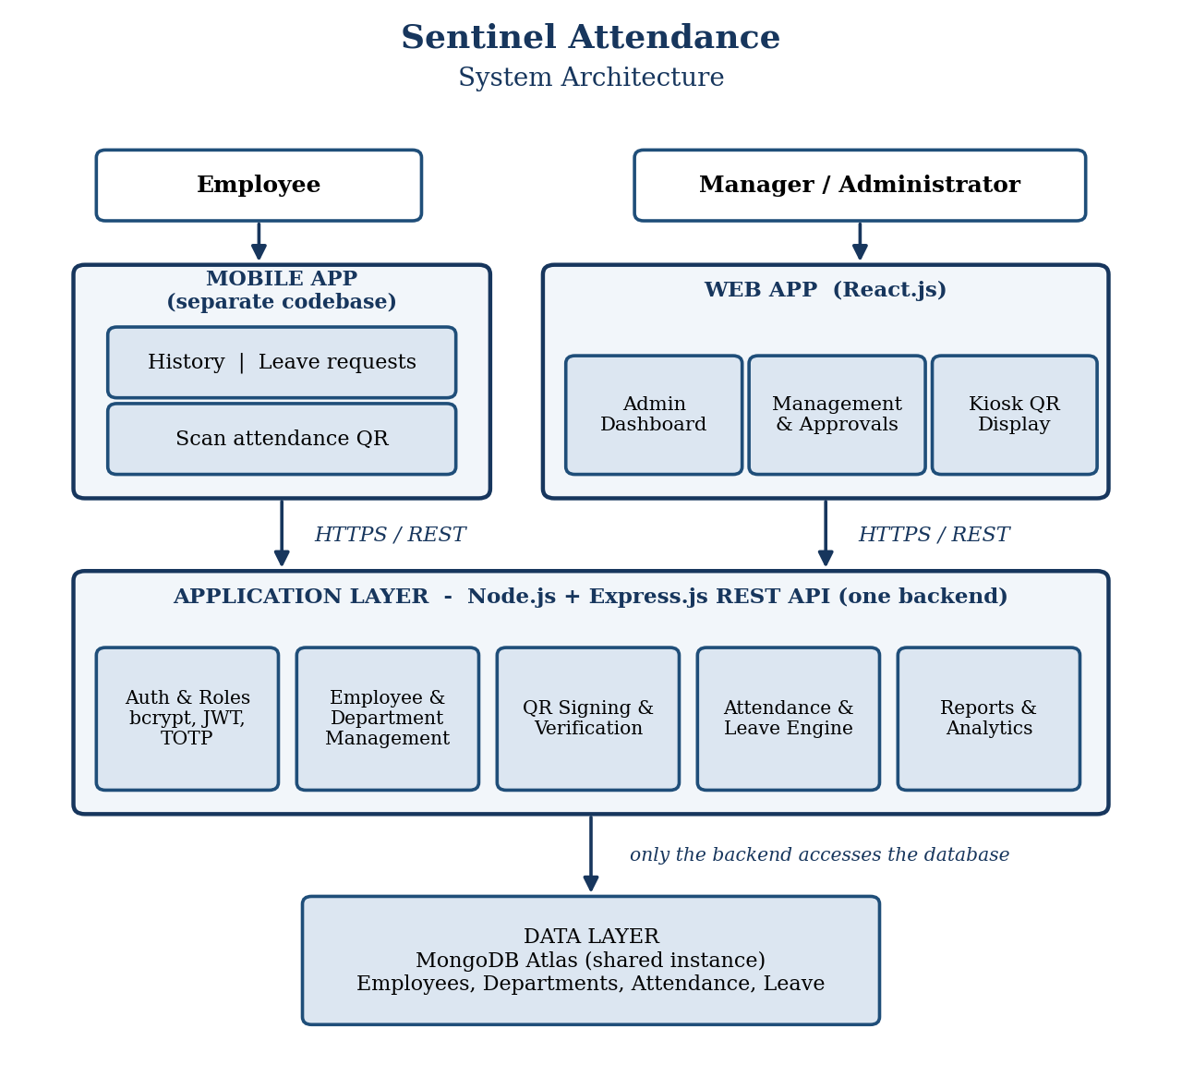
Figure 8.1: System Architecture of Sentinel

9. MAJOR MODULES
The system is divided into four modules, one per team member.
Module | Title | Team member
Module 1 | User Authentication & Employee Management | Melbin Paul
Module 2 | Smart Attendance & QR Verification | Aivin Jinu
Module 3 | Admin Dashboard & Analytics | Amina Salim
Module 4 | Leave Management & Employee Self-Service | Nandana Rajendran

9.1 Module 1: User Authentication & Employee Management
This module provides shared login and role-based access for the web application, TOTP two-factor authentication for Manager and Administrator accounts, and employee and department record management. Passwords are hashed with bcrypt, and verified sessions are issued as signed JWTs by the backend. Employees do not log into the web application. Their accounts are created by an Administrator through this module and are used only to authenticate on the mobile app. Manager and Administrator login requires both the account password and a time-based code from an authenticator app.

9.2 Module 2: Smart Attendance & QR Verification
This module implements the core attendance mechanism. The backend generates and signs rotating QR codes and regenerates them every few seconds. A kiosk-facing display shows the current code at the office premises. When an employee scans it, the mobile app calls the verification endpoint, which checks the signature and expiry, prevents duplicate scans, and then computes working hours and attendance status. Because each code expires within seconds and cannot be regenerated without the server’s private signing key, a screenshotted or shared code cannot be reused once it has expired.
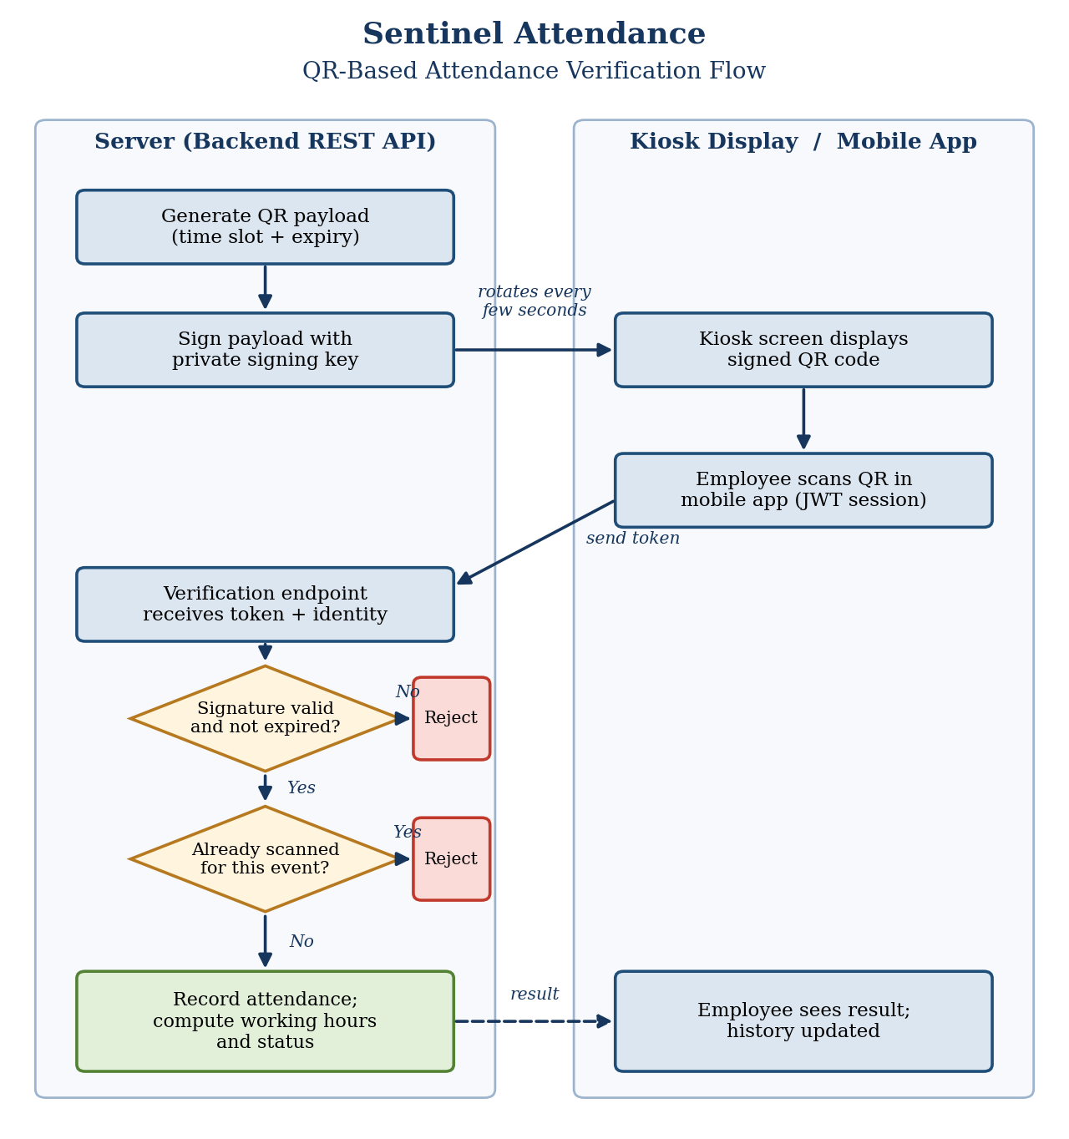
Figure 9.1: QR-Based Attendance Verification Flow

9.3 Module 3: Admin Dashboard & Analytics
This module gives Administrators a live dashboard covering attendance trends, absenteeism and late-arrival analytics, and department-wise comparisons. It also provides organisation-wide report generation and export for planning and review.

9.4 Module 4: Leave Management & Employee Self-Service
On the mobile side, employees submit leave requests and track their status. On the web side, Managers and Administrators review and approve or reject requests through an approval workflow. Once a request is approved, it is reconciled automatically into the attendance records, so no manual correction is needed. Employees can also view their own attendance history from the mobile app.

10. DATA DESIGN AND STORAGE
Application data is stored in a single MongoDB Atlas database that is shared by both clients but accessed only through the backend. The data model is organised around the logical entities below. This is a proposed design derived from the system description, and the final field names and structures should be confirmed against the implemented schemas.
Entity | Key information stored
User / Employee | Name, contact details, department, role (Employee, Manager, Administrator), password hash, and, for Manager and Administrator accounts, TOTP enrolment details.
Department | Department name and the employees or managers associated with it.
Attendance record | Employee reference, date, check-in and check-out times, computed working hours, status (for example present, late, or on leave), and information used to detect duplicate scans.
Leave request | Employee reference, leave dates, reason, status (pending, approved, or rejected), and the reviewing Manager or Administrator.

Passwords are stored only as bcrypt hashes. The private key used to sign QR codes is held only on the server and is never sent to either client. Database connection strings, JWT secrets, signing keys, and other private configuration values are supplied through environment configuration and must not be included in this report or in any shared source archive.

11. IMPLEMENTATION OVERVIEW
- The web application is a React.js single-page client for Managers and Administrators. It contains the dashboard, employee and department management, report screens, leave approval screens, and the kiosk-facing QR display.
- The mobile application is a separate codebase for Employees. It supports sign-in, QR scanning, attendance history, and leave submission and tracking, and communicates only with the backend REST API.
- The backend uses Node.js and Express.js. It applies authentication middleware, enforces role checks, and exposes REST routes for authentication, employees and departments, QR codes and attendance, leave, and reports. It is the only component that connects to MongoDB Atlas.
- An Administrator creates employee accounts in the web application. Employees then sign in on the mobile app with backend-verified credentials and receive a signed JWT. Manager and Administrator accounts additionally provide a TOTP code when signing in on the web.
- The backend generates a QR payload with an expiry time, signs it with its private key, and refreshes it every few seconds. The kiosk display shows the current code.
- When the mobile app submits a scanned code, the verification endpoint checks the signature and expiry, rejects duplicate scans, and then records the attendance and computes working hours and status.
- When a Manager or Administrator approves a leave request, the backend reconciles the approved leave into the attendance records automatically.
- For local development, start the backend with its environment configuration and the MongoDB Atlas connection, then start the React development server and run the mobile app against the same backend, using the commands in the project README.

12. LIMITATIONS
- The security of the QR mechanism depends on keeping the private signing key confidential and on a suitable code refresh interval.
- Attendance can be recorded only when the employee’s phone has a working camera and a network connection to the backend.
- A kiosk display showing the QR code must be available at the office premises.
- The web and mobile applications are separate codebases that must stay compatible with the same backend API.
- Employees have no web access, so all employee self-service depends on the mobile application.
- Manager and Administrator sign-in on the web requires an authenticator app for TOTP codes.
- Location-based validation and biometric verification are not part of the described scope.
- No performance, usability, security, or reliability results are claimed because formal test results have not yet been recorded.

13. FUTURE ENHANCEMENTS
- Add location or network-based validation to confirm that a scan is made from the premises.
- Introduce biometric or face verification as an additional check.
- Support multiple offices or branches, each with its own QR display.
- Integrate with payroll and HR systems.
- Add push notifications for leave decisions and attendance reminders.
- Provide shift scheduling and overtime tracking.
- Conduct systematic security, usability, and performance testing, and deploy with secure key management, logging, backups, and monitoring.

14. CONCLUSION
Sentinel replaces a manual attendance process with one that is automated and tamper-resistant. It is split cleanly between an admin-facing web console and an employee-facing mobile app, both of which are clients of a single backend that enforces every validation rule in one place. Its four modules deliver secure two-factor authentication and employee administration, QR-based attendance verification with signed, short-lived codes shared across two client applications, administrative analytics, and end-to-end leave management with employee self-service. The design keeps each module substantial and demonstrable while remaining within the scope of a four-member team. The test cases in this report should be executed on the final build, and future work can extend the system with location validation, biometric checks, and payroll integration.

REFERENCES
- Sentinel project abstract and module allocation, Department of Computer Applications, Saintgits College of Engineering, 2025-27.
- M’Raihi, D., Machani, S., Pei, M., and Rydell, J., “TOTP: Time-Based One-Time Password Algorithm,” RFC 6238, Internet Engineering Task Force, 2011.
- Jones, M., Bradley, J., and Sakimura, N., “JSON Web Token (JWT),” RFC 7519, Internet Engineering Task Force, 2015.
- React documentation, https://react.dev
- Node.js documentation, https://nodejs.org/docs
- Express.js documentation, https://expressjs.com
- MongoDB Atlas documentation, https://www.mongodb.com/docs/atlas

